**Data Migration Assistant**

1. Click the + sign to create a new project:

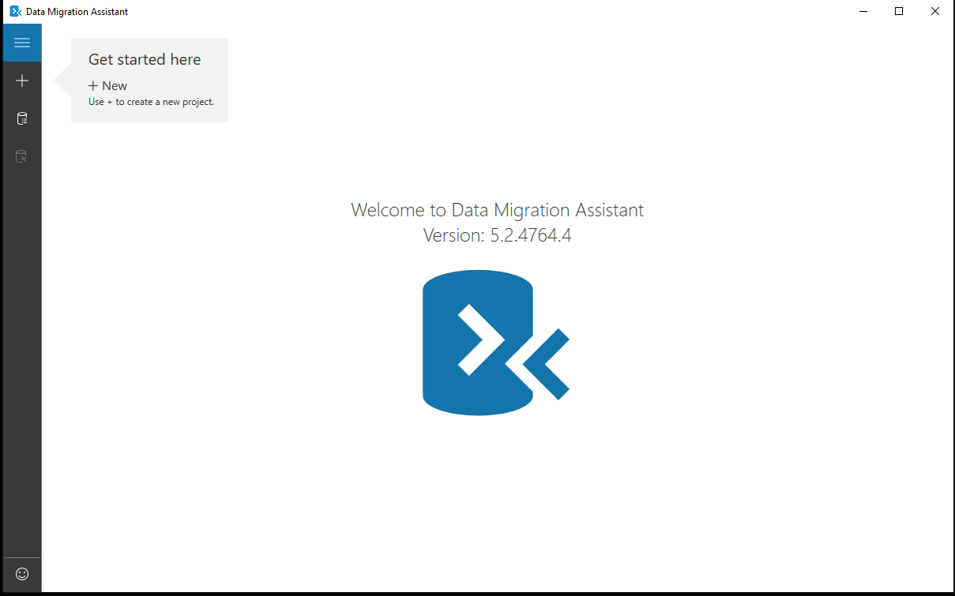

1. Fill in project details and click ‘Create’:

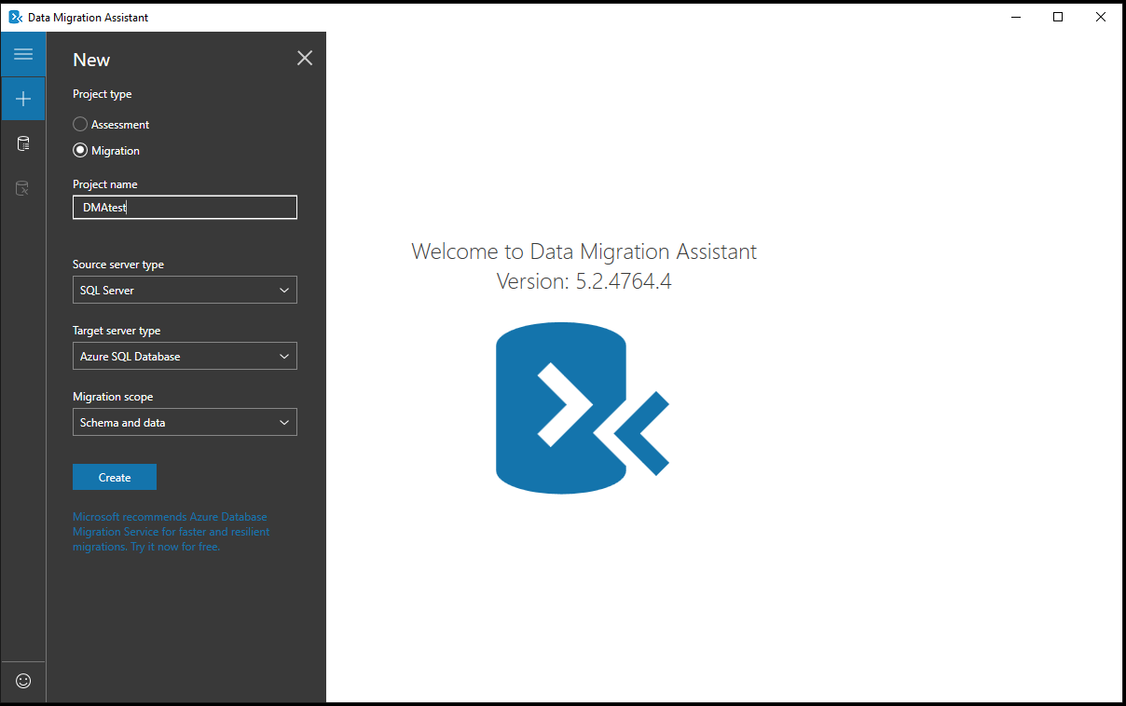

1. Fill in connection information for the source server:

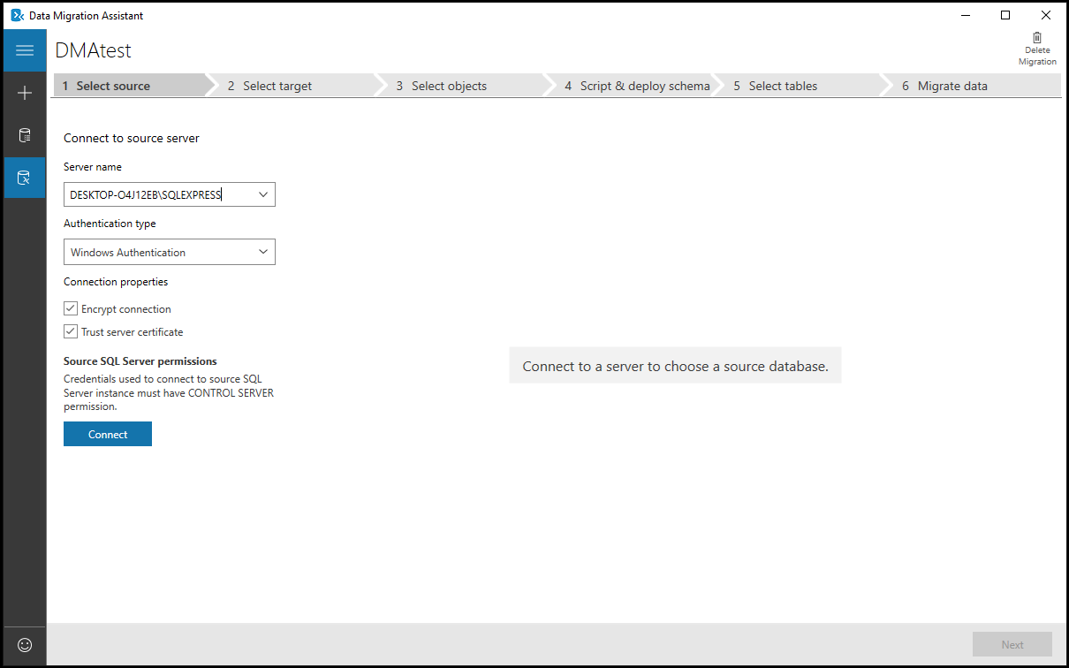

1. Select the database to be migrated, then click Next:

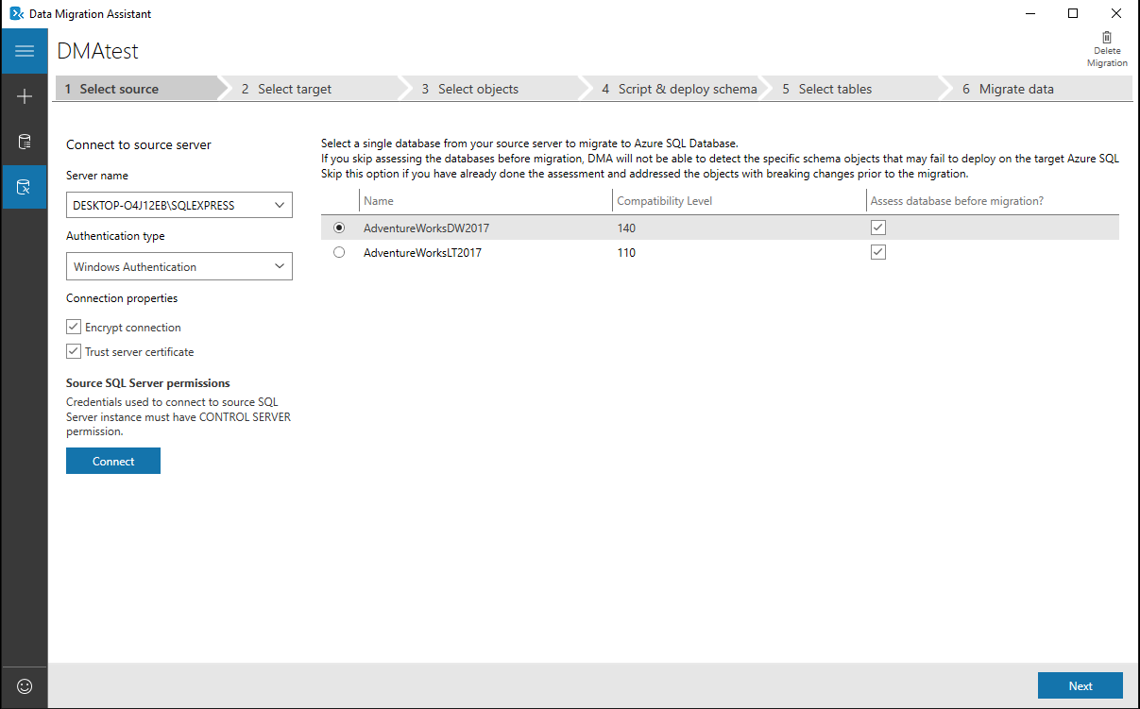

1. Fill in connection information for the target server:

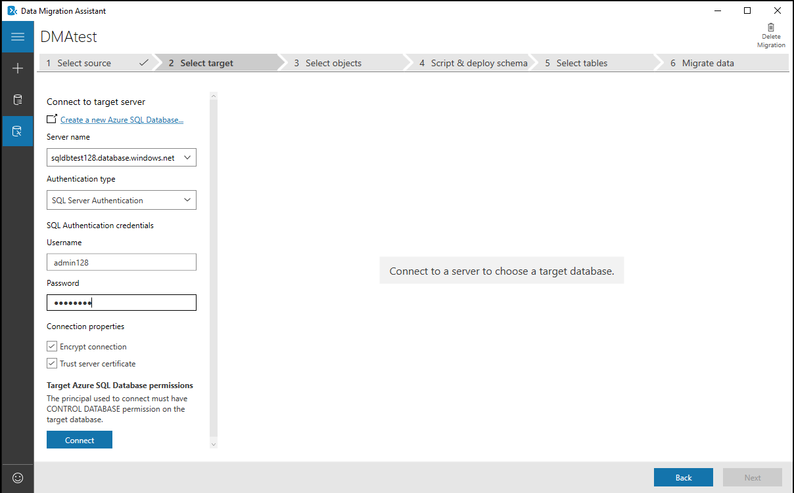

1. Select the target database, then click ‘Next’:

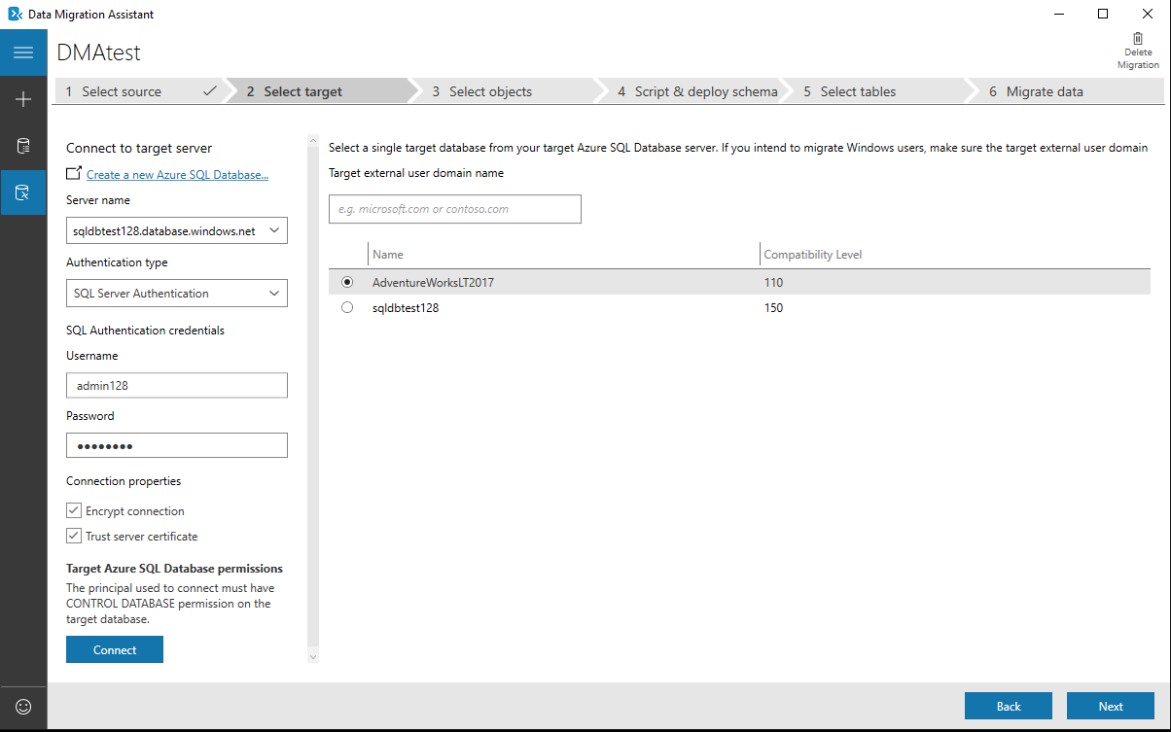

1. Select the objects to be migrated, then click ‘Generate SQL Script’:

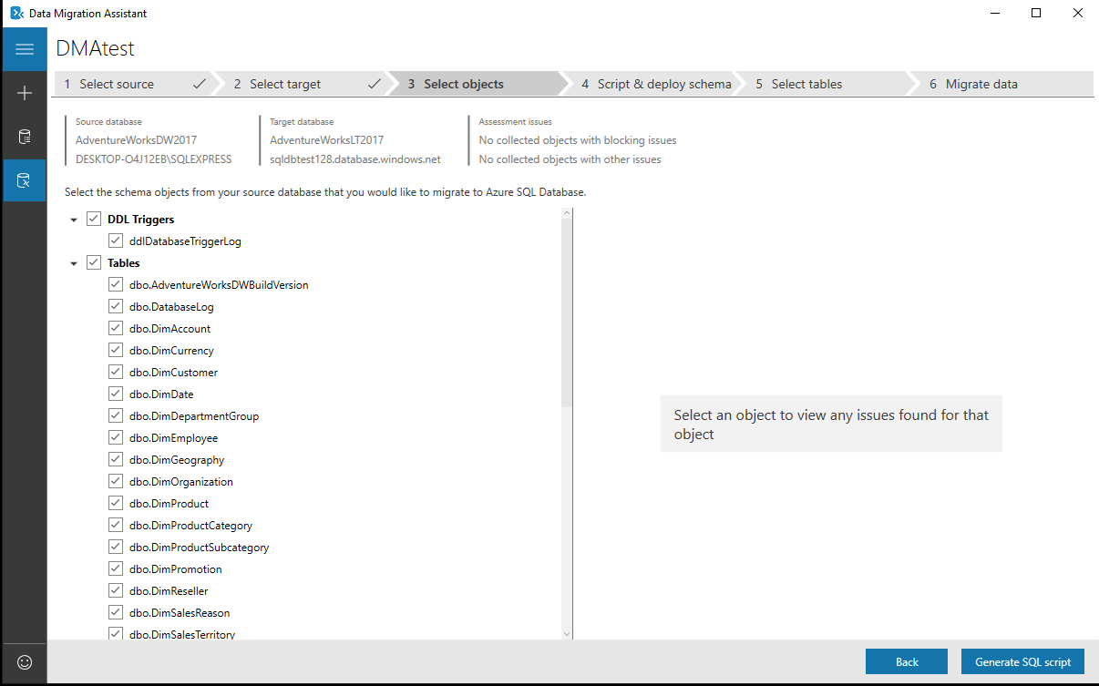

1. The SQL script will be shown, then click ‘Deploy Schema’:

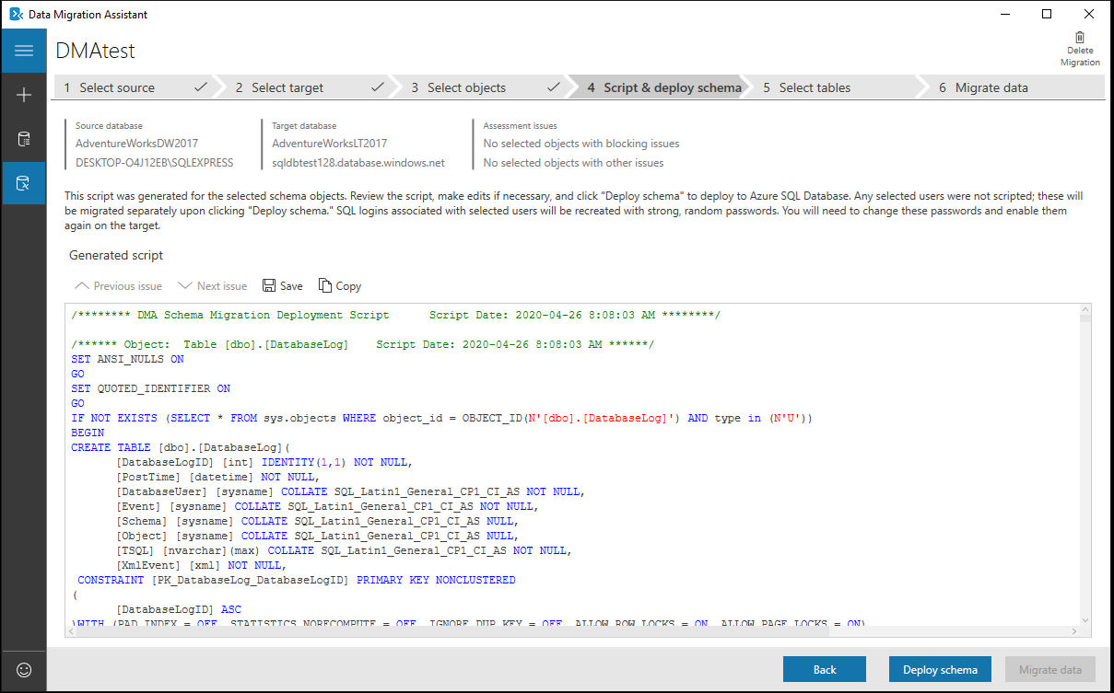

1. The schema will deploy to the target server:

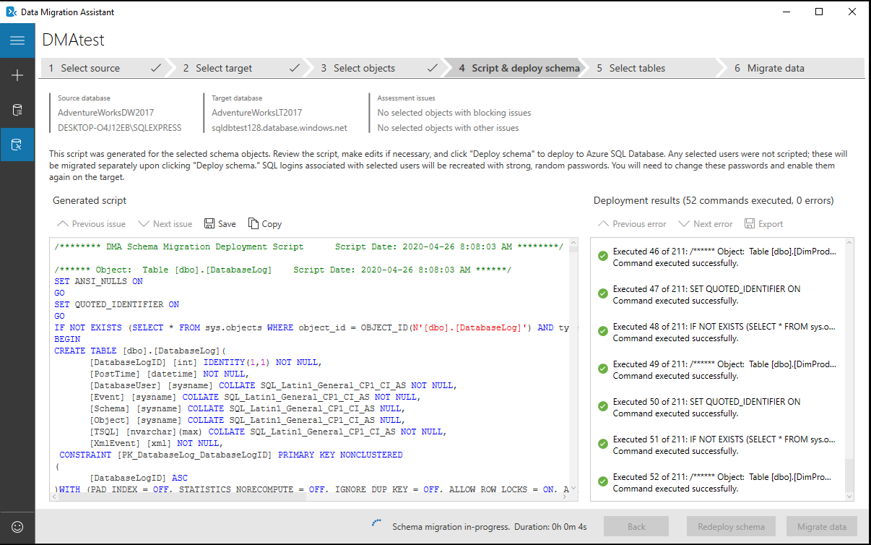

1. Click the ‘Migrate Data’ button:

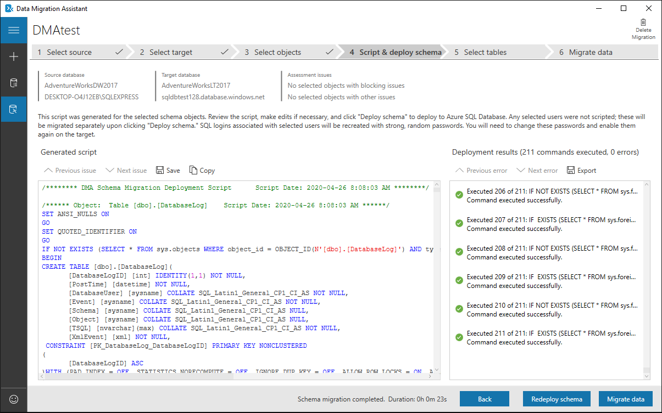

1. Select tables to migrate and click the ‘Start data migration’ button to start the migration:

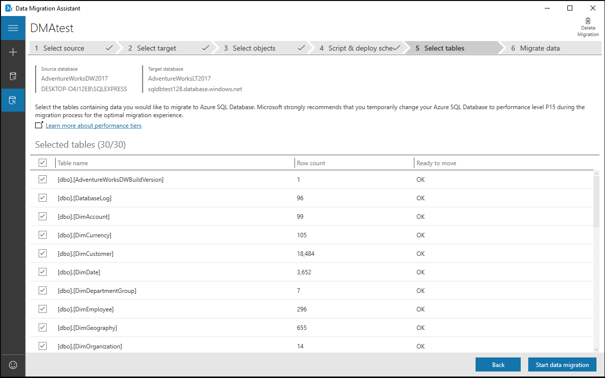

1. The data will be migrated to the target:

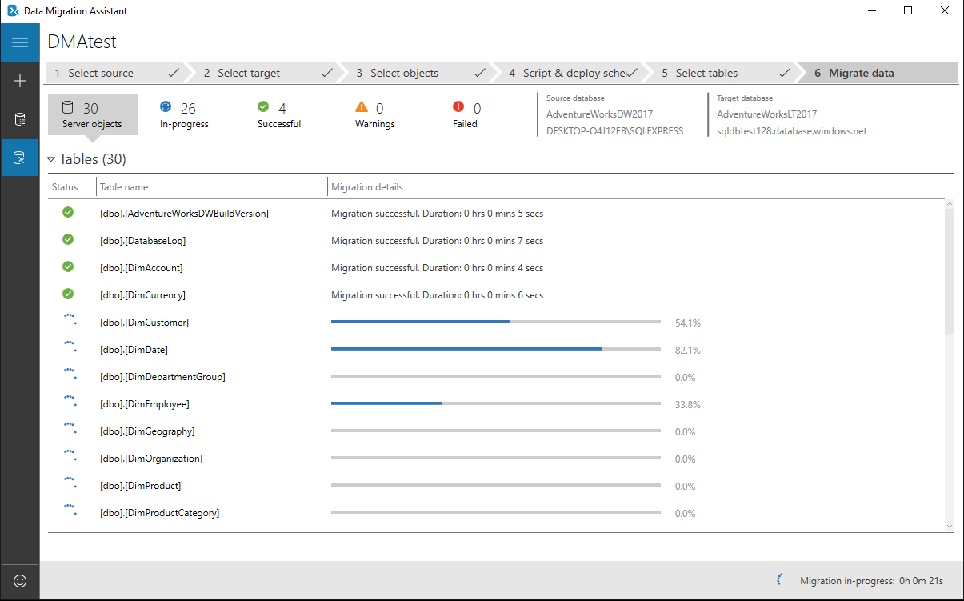

1. Once the migration is completed, it will successful and failed statistics:

